**Mid-Term Exam EGR-334 Fall 2018**

**Sample Exam**

**Analog - Digital Interface**

**Name: _______________________**

**Note: All problems weighted equally. Show your work on all problems to receive partial credit.**

1. **Give a Signal at a Frequency of 18 MHz Determine the Wavelength λ.**

**[Principles of Electronic Communications 4th Edition Chapter 1]**

**a) 17 EE -6 meters**

**b) 5.40 EE 9 meters**

**c) 18 EE 6 meters**

**d) 16.66 meters**

1. **Given a Signal that Occupies a Frequency Range from 1.050 MHz to 1.175 MHz Determine the Bandwidth.**

**[Principles of Electronic Communications 4th Edition Chapter 1]**

**a) 1.70 MHz**

**b) 125 kHz**

**c) 2.225 MHz**

**d) 1.6375 MHz**

1. **A SSB Transmitter produces a 400 V PEP Signal across a 52 Ω   
   Antenna Load, Determine the PEP Output Power.**

**[Amplitude Modulation Fundamentals Chapter 3 pdf]**

**P=V^2/R**

**a) 192.2 W**

**b) 384.5 W**

**c) 769.2 W**

**d) 3077 W**

1. **An AM Broadcast Station Operates with its Total Licensed Power Pt (PEP) of 500 kW and 95% Modulation Index, Please Determine the Stations Carrier Power Pc.**

**[Principles of Electronic Communications 4th Edition Chapter 1]**

**Pt=Pc(1+m^2/2)**

**a) 22.36 W**

**b) 250 kW**

**c) 345 kW**

**d) 353.5 kW**

1. **The Signal Level at the Input to an Amplifier is 0.5 Vrms. The Noise Level at the Input at the Input is 2.5 mVrms. Please Determine the S/N Ratio at the Input of the Amplifier in dB.**

**[The Art of Electronics 3rd Edition Chapter 8]**

**SNdb=20log(Vs/Vn)=10log(Ps/Pn)**

**a) 88 dB**

**b) 67 dB**

**c) 53 dB**

**d) 46 dB**

**e) 35 dB**

1. **Given Two Filters a BP and BR. The First BP Filter allows Frequencies between 7.25 kHz and 1.125 MHz to Pass. The Second BR Filter Blocks Signals of Frequencies between 8.25 kHz and 9.75 kHz. Connecting the Two Filters in Sequence will Result in the Following Range of Frequencies to Pass on to the Next Stage.**

**[Boylestad 11th Edition Chapter 11]**

**a) 7.25 KHz to 9.75 kHz**

**b) 8.25 kHz to 1.125 MHz**

**c) 0.0 Hz to 8.25 kHz and 9.75 kHz to 1.125 MHz**

**d) 7.25 kHz to 8.25 kHz and 9.75 kHz to 1.125 MHz**

1. **Given the following Bode Plot; Please Determine the Output of the Filter Expressed in Vpp when an Input Signal of 5.5 Vpp is Applied at the Input of the Filter @ Frequency of 2 Hz.**

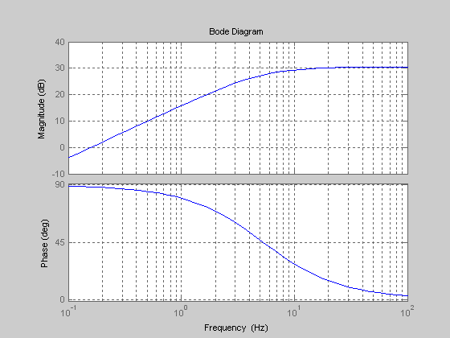

**Vout is Closest to,**

**a) 11.0 Vpp**

**b) 115.50 Vpp**

**c) 5.5 Vpp**

**d) 61.71 Vpp**

**e) 692.40 Vpp**

1. **For the RC4558 Data Sheet Bode Plot Shown Below, Please Determine the Approximate -3 dB Cutoff Frequency.**

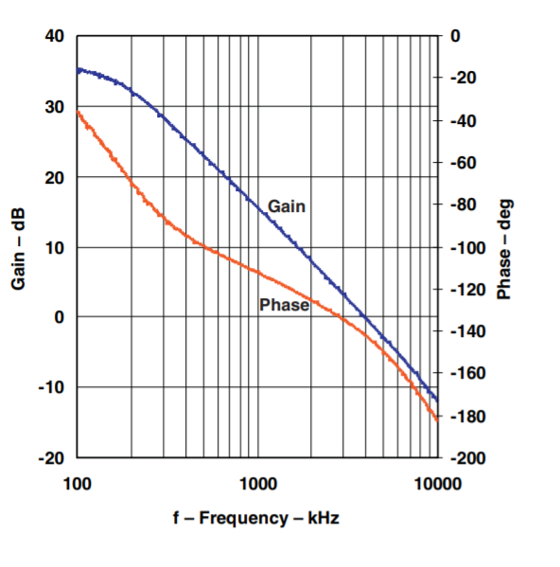

**a) 5000 HZ**

**b) 5 MHz**

**c) 4000 Hz**

**d) 4 MHz**

1. **Referring to the Belden RG58U/1 Coaxial Cable Data Please Determine the Power Input Requirement to Achieve and Output Power of 100 W @ 960 MHz for a Cable 65 Feet in Length.**

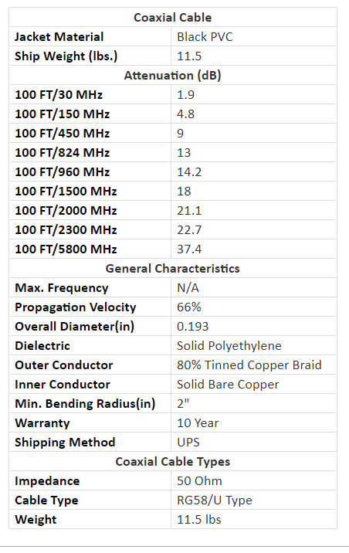

**a) 837.52 W**

**b) 289.40 W**

**c) 2.63 kW**

**d) 512.86 W**

1. **For a Given Operational Amplifier Please Determine the following Quantities,**

**Amid Voltage Gain = 275 f1 = 60 Hz f2 = 100 Hz**

**Voltage Gain @ 5 Hz**

**a) 42.42**

**b) 22.83**

**c) 7.07**

**d) 33.33**

**Voltage Gain @ 250 Hz**

**a) 102.13**

**b) 70.70**

**c) 194.42**

**d) 140.00**

**Voltage Gain @ f1 and f2**

**a) 247.45**

**b) 350**

**c) 175**

**d) 10 EE +3**

1. **For the Bandpass Filter Shown Below, Please Calculate the Following Quantities,**

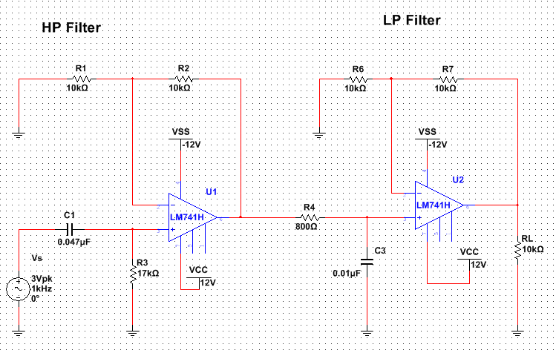

**Lower Cutoff fc**

**a) 20 kHz**

**b) 200 Hz**

**c) 5.63 Hz**

**Upper Cutoff fc**

**a) 56.29 Hz**

**b) 200 Hz**

**c) 20 kHz**

**BW**

**a) 19.8 kHz**

**b) 200 Hz**

**c) 20.20 kHz**



**Assuming the Operational Amplifiers are Operating within Specifications Please Determine the Following,**

**Voutpp @ 60 Hz ____________**

**Voutpp @ 30 kHz ___________**